However, on the 4th day of the campaign, a video capitalizing on the same school incident started to circulate on Facebook that according to social listening tools of UNICEF revealed that “it’s getting increasing views”. The video under discussion was false narrations against immunizations with baseless foundation of the Peshawar incident video by a famous scholar of Dir Uppar.

Dr. Muhammad Arif, Director EPI KP took notice of the video and sent Mr. Asad Zia, Communications Officer, EPI KP on a special assignment to visit Dir Upper in-person and resolve.
Mr. Asad, left Peshawar right away and started to coordinate with the scholars of Peshawar and Dir Upper capitalizing on the existing working relationship. Mr. Asad had a series of in person meetings with the community influential trying to convince them on evidence based approach how this video can be threatening to the campaign. The community influential (most of whom were already EPI Ambassadors) took notice of the video and the video was not only removed rather the scholar had to upload an explanation video rebutting his own words those were uttered in negligence and misinformation.

The above incident is another feather and a huge success for EPI diaries, as the Ministry of National Health Services Regulations 7 Coordination considers “Crisis Communications and Community Engagement” (RCCE) as one of the most prioritized component. The same component this very case enabled EPI KP to successfully continue the campaign that concluded with 100% target achievement with inoculation of 2992,683 children.

Crises, be it real or fabricated are newsworthy and are capable of weakening trust in vaccines and vaccination. It is a very small window between an event and ‘it’ becoming a story.

It was 3rd Oct, 2022, the first day of the Typhoid Conjugate Vaccine (TCV) Campaign in Peshawar where the front line health care workers were busy in inoculating children with TCV vaccine suddenly a news started to flash on one of the mainstream media channel stating around 25 girls have lost their consciousness after the TCV jab and have been moved to hospital.

The EPI KP top level management that was busy in the inauguration along with all members of Federal Directorate of Immunization (FDI’s) Crisis Communications Cell (CCC) started crisis communication to regain, maintain and even strengthen trust in vaccines, vaccination, and immunization program of Pakistan.

Alhamdulillah, with a matter of few hours of collective effort of all (CCC) Members from National Command and Operation Center (NCOC), Federal Directorate of Immunization (FDI), Expanded Programme on Immunization (EPI) KP, Polio Eradication Initiative (PEI), John Snow Inc. (JSI-USAID), Pakistan Pediatric Association, The Society of Obstetricians & Gynecologists of Pakistan (SOGP) and Pakistan Medical Association (PMA), the matter was resolved within hours.

The operations were supervised directly by the national team lead Dr. Muhammad Ahmed Kazi, Director General, Federal Directorate of Immunization. Case investigations revealed that it was the ambulance driver of a humanitarian organization (Edhi), who was called after the school management misinterpreted girl’s orthodox psychological reaction to injection fear as a serious AEFI.

Kudos to the EPI Team, all went to normal within hours and campaign in all selected districts inclusive of Peshawar continued with total normalcy. However, the mainstream video kept on echoing on different social media platforms. EPI Team kept the track and responded and resolved successfully all these manipulative circulations on social media, surfacing on repetitive basis.

Mr. Asad Zia, Communications Officer, EPI KP interacting with scholars
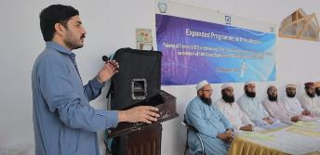
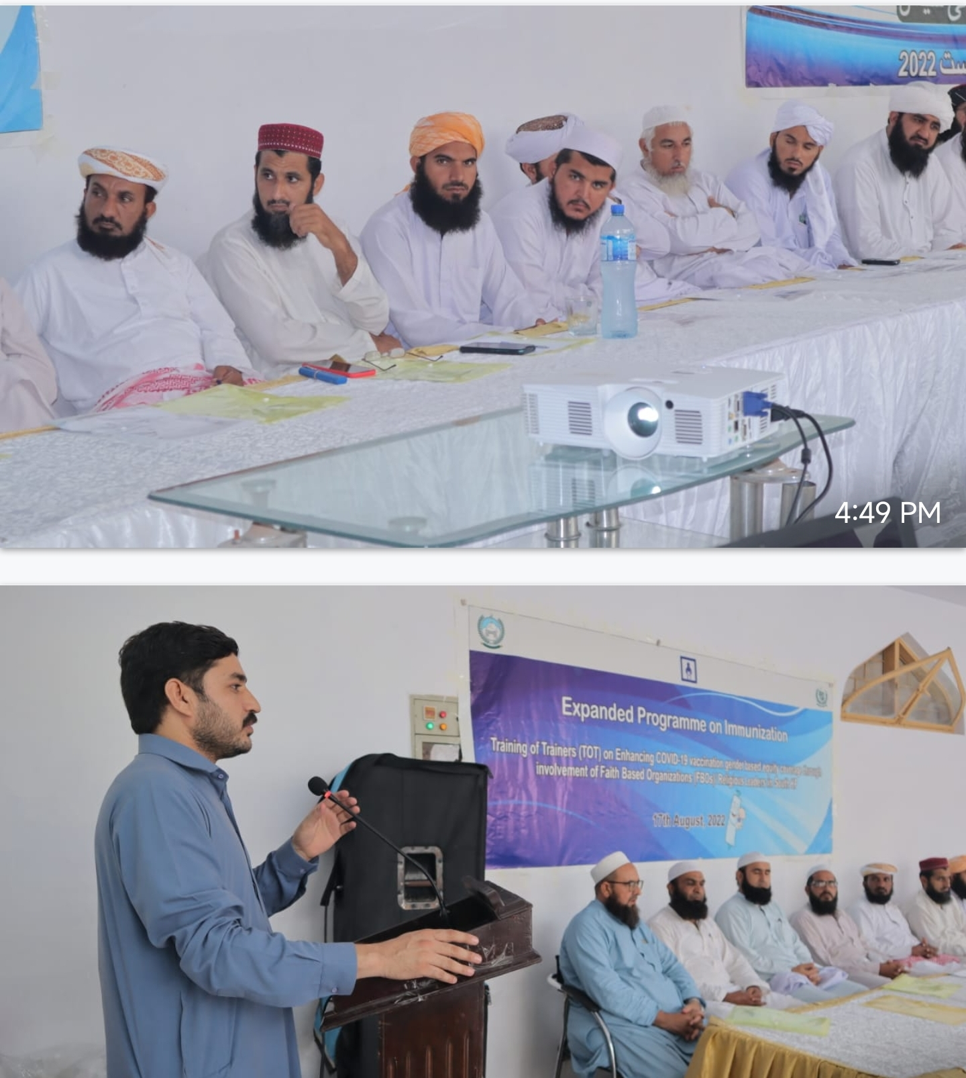

A routine AEFI matter in a Girl’s School of Peshawar unintentionally landed in the media: FDI crisis communications cell success story built on promptness, honesty and transparency.




Case Study

